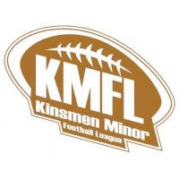
Support Your Sport Silent Auction
Dear Friends and Family,
Starting Monday April 6th, and running until Wednesday April 8th, 2020
the Kinsmen Club of Peterborough, will host their 13th annual
Support Your Sport Silent Auction!!
In our 13th year the message is still the same;
Support the children in our community that may not be able to afford the costs of minor sports. We
create a platform that brings together the major associations in Peterborough to help lower the costs
to families by supporting these groups with much needed equipment, jerseys, rising ice time fees or
field maintenance fees, creating a better sports experience for all.

We kindly ask that you consider providing an item for our Silent Auction.
The Support Your Sport event runs one of the largest and unique silent auction in the Kawarthas.
Our auction is seen by over 3000 people, and growing!
All of our sponsors will be recognized in all of our media coverage
Community paper, local T.V, Radio Ad's, and of course throughout the entire Silent Auction
Any support, big or small is GREATLY appreciated.

If you have any questions, or would like your item picked up, please feel free to contact us any time;
Reed Manley- rmanley@cogeco.net 705-808-5246
Darrel Junkin- craftworks@cogeco.net 705-750-1010
Dave Ronson – kindaver@gmail.com 705-775-1328
On behalf of all our Associations, we would like to thank you in advance for your continued support.
The action, as always, is at the
Kinsmen Arena, 1 Kinsmen Way
Peterborough, Ontario
On behalf of all our Associations, we would like to thank you in advance for your continued support.

